**COLOUR DETECTION**

Ambuj Porwal *Department of Computing Technologies (*CTECH*)*  
*SRM Institute of Science and Technology*Chennai, India  
ap1684@srmist.edu.in

Sajal Tyagi  
*Department of Computing Technologies (*CTECH*)*  
*SRM Institute of Science and Technology*Chennai, India  
st8287@srmist.edu.in

Dr.R Rajkamal   
*Department of Computing Technologies (*CTECH*)*  
*SRM Institute of Science and Technology*Chennai, India  
rajkamar@srmist.edu.in

*Abstract*— This paper shows implementation of Colour detection is the process of detecting name of the colour. Here this is easy task for humans to detect the colour and choose one.We have build a system through which user can automatically receive the name of colour by just clicking on the spot.For this colour picking procedure we have a data file that contains 865 colors and its value respectively.After that we can calculate the most closest colour to which you chosen.Which will be helpful for colour blind people a lot.

Keywords—Detection , machine learning models,supervised and unsupervised learning,Gaussian pyramid,laplacian pyramid.

# Introduction

We are focusing on one of the category of disable people that is colour blind people.It is a disability in which the person suffering from it is unable to see some colors (fun fact: his/her vision is not black and white) the colors not visible depends on type of Color Blindness. This disability makes a person impaired from doing task which involves selection of colors like choosing clothes, buying vegetables, fruits or even while travelling (Traffic lights or other cars lights).

For there ease we have two type of colour detection modes that 1)Normal(Hovering)mode 2)Live(Web-Cam)mode.In normal mode we require a photo which we will take as input and clicking anywhere on photo will give output as colour name.

And the live mode will give output as colour name whatever object will come under pointer given on window .This project also have image enhancement process which enhance the input image and bring the true colors of that image.

Self-drive cars are the future and they require color detection to easily commute on road.But right now what we can do to at least is to solve this issue temporarily (not close to reality but start is always small). Recognition of colors from an image and then from live video has been done by many, we have also tried to do the same. We have successfully detected color in the image, now in the next step we are going to implement the live video color detection. In the program the R,G,B values of colors are to be compared with the that of the image and then display the name of the color that will be easily visible to the user, this system can help in knowing the colors to normal people(especially men) and hence this system can be very useful and it do have the future use for like connecting this system in the goggles or specs and also in helmet for those driving motorcycle, these all things might seem of no use now or to most people but all those people suffering from it most probably find it very useful.

# State of the art (LITERATURE SURVEY)

## 2017,Su, Feng, Gu Fang, and Ju Jia Zou. "A novel colour model for colour detection." Journal of Modern Optics 64, no. 8 (2017): 819-829.

## 2015,Sawicki, Dariusz J., and Weronika Miziolek. "Human colour skin detection in CMYK colour space." IET Image Processing 9, no. 9 (2015): 751-757.

## 2021,Tariq, Abdullah, Muhammad Zeeshan Khan, and Muhammad Usman Ghani Khan. "Real Time Vehicle Detection and Colour Recognition using tuned Features of Faster-RCNN." In 2021 1st International Conference on Artificial Intelligence and Data Analytics (CAIDA), pp. 262-267. IEEE, 2021.

## 1994,Matas, Jirí, Radek Marík, and Josef Kittler. "Illumination Invariant Colour Recognition." In BMVC, vol. 94, pp. 469-479. 1994.

## 2015,B. R. Navada, K. V. Santhosh, S. Prajwal and H. B. Shetty, "An image processing technique for color detection and distinguish patterns with similar color: An aid for color blind people," International Conference on Circuits, Communication, Control and Computing, 2014, pp. 333-336, doi: 10.1109/CIMCA.2014.7057818.

# Proposed Work

From this paper read,it is very clear that we have completed this normal mode and live mode of colour detection with python language with using modules which already shown above .

Colour is basically the mixture of three major colors that is red , green and blue In computer language,We define each color with the unique set of three values and value should not exceed 255. So the total number of colors can be represented by giving the different values to R,G,B in a set and the number of possible colors are 16,581,375(256x256x256).

For picking colour,we need a data set which has colour name along with it the R,G,B values respectively which define each colour different from others.

As we are using data set so it is clear that be are using supervised learning algorithm which classified values of R,G,B in different columns.And K-Means is helping choosing the most similar colour from the data set .

In live mode colour detection is done in HSV colour format not in BGR.Here all colors are dependent on H(hue) value not on other value.

For Image Enhancing we are using MATLAB , in that we are implementing Gaussian and Laplacian pyramid algorithms and other methodology like white balancing,gamma correction,red compensate,etc.

## Architecture Diagram

An architectural diagram is a visual representation that maps out the physical implementation for components of a software system. It shows the general structure of the software system and the associations, limitations, and boundaries between each element.

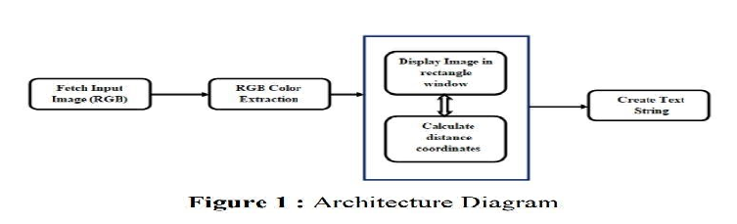

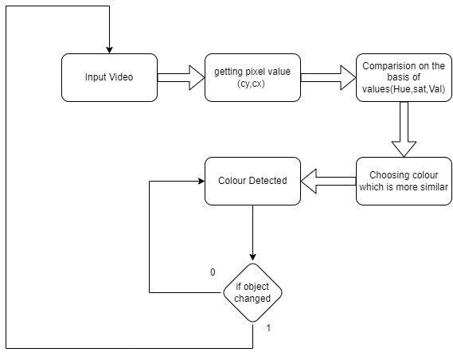

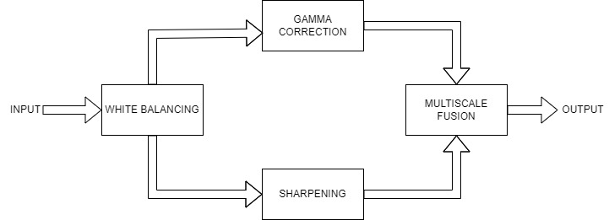

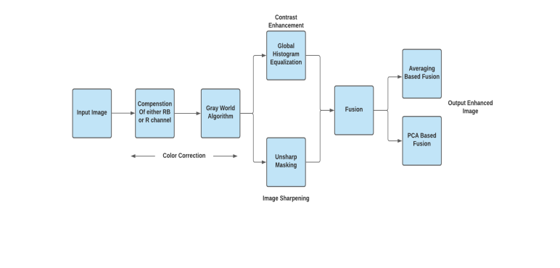

## Screen sorts

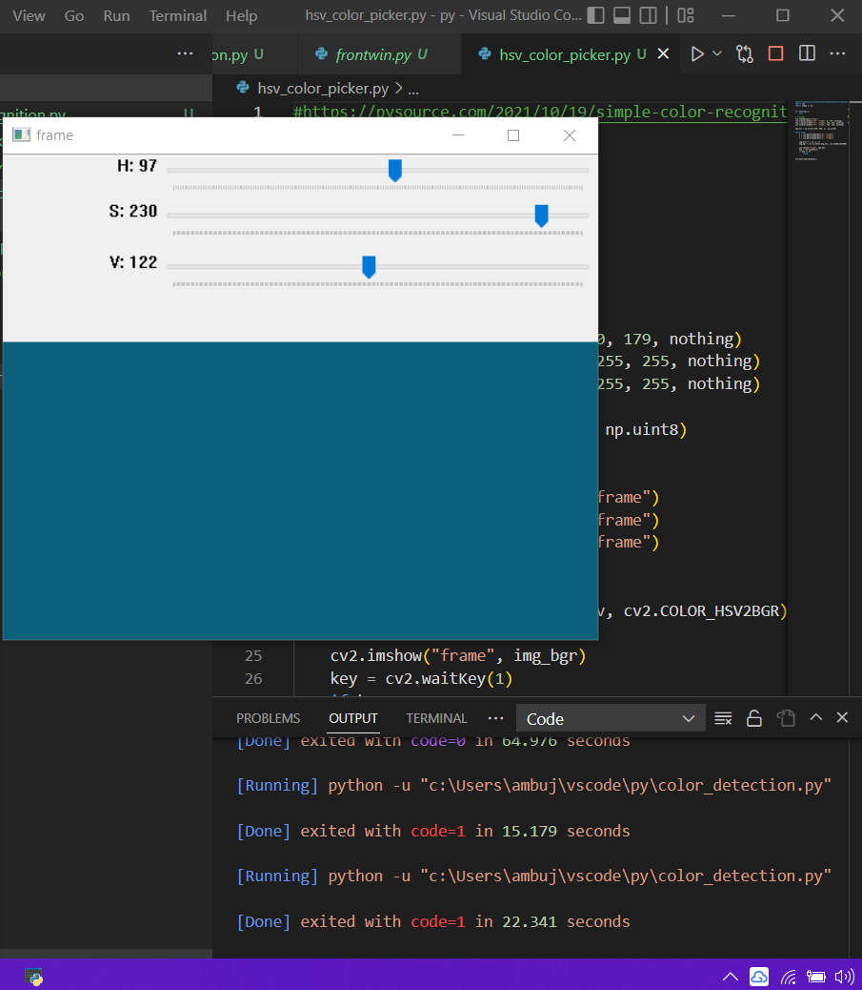

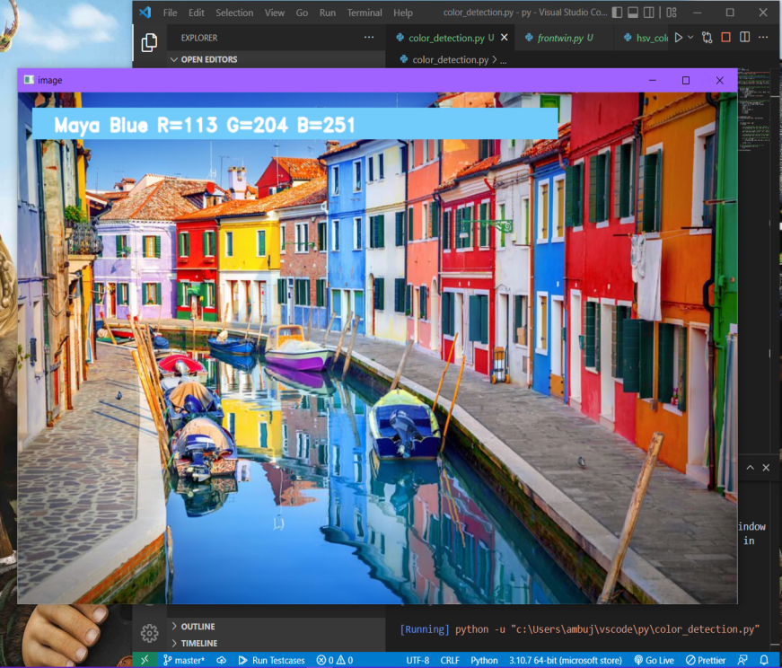

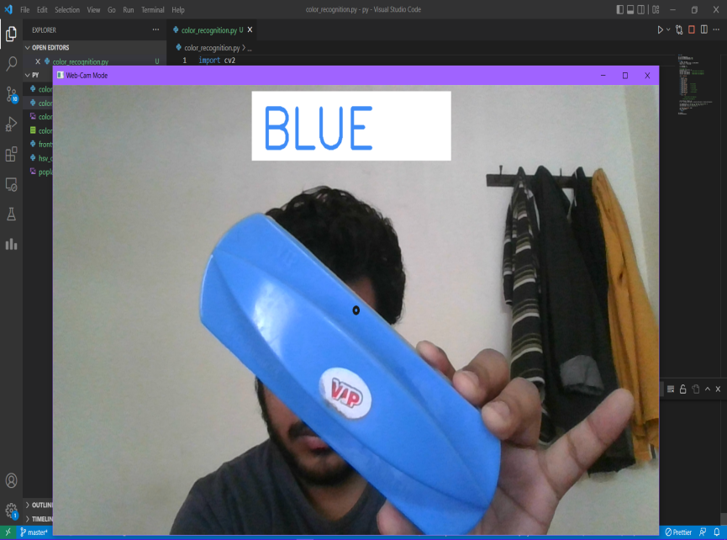

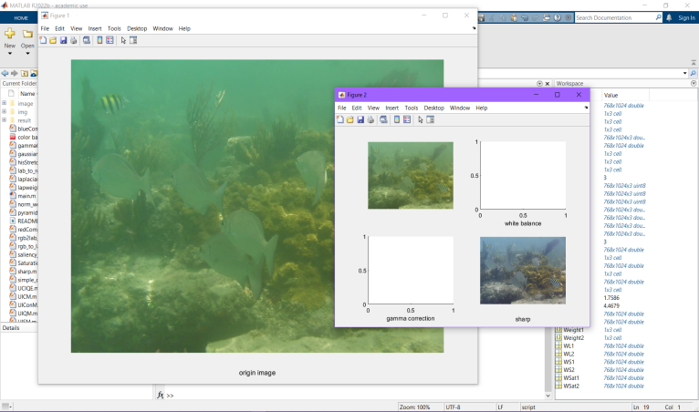

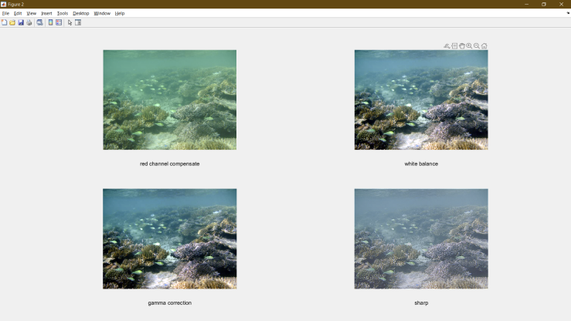

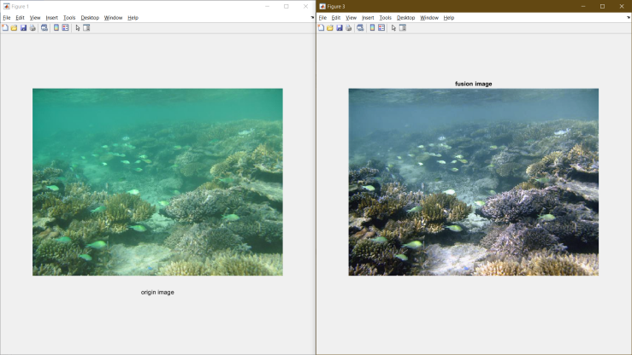

# Implementation

When we have to work with CSV files for that pandas library play a major role in performing various operations on data file.

And pd.read_csv() reads the CSV file and push it into the pandas data frame.We have given name and unique name to each column for easy access.

Firstly we created a window in which the input photo will be shown as output.Then, we created a callback function which will be called when mouse clicking happens.

We do have to double click on the particular spot and then it will read or calculate the RGB value and this is done with the help of (x,y) function which simply finds the coordinates which means the exact position of mouse where will double click.After that it will be converted into R,G,B values.

We have the RGB values. Now another task is to return the colour name w.r.t R,G,B values.For that we have a formula :*d = abs(Red — ithRedColor) + (Green — ithGreenColor) + (Blue — ithBlueColor).*

Which will help to find the most closest colour we can find and this all about the idea for hovering mode.

Whenever a double click happen then it will automatically display the name of colour and with that the real RGB values which was calculated.And using cv2.imshow() function, we draw the image on the window.when the user click on the window it will draw a rectangle and in that colour name and the RGB values will be there within the rectangle.

And for second mode first we get values of BGR from image and then convert to HSV.it is because we cannot go for BGR because if we change any of the value from B,G,R then colour changes but in HSV format on H value needed to see any colour.Because S value is for quantity of colour and V value is for Brightness of colour.

# Results discussion

We successfully present our two modes of colour detection with image enhancement for colour blind people and for future self drive cars which need colour detection on road to identify the direction.

# Conclusion

Color detection technology has come a long way and has a long way. When we see self-driving cars driving on the roads according to road traffic rules. Today,the machines are ready for it. Tesla is a pioneer in this technique. However, next-generation color detection programs will have multiple upgrades. Application in smart environment - where computers and equipment are similar to assistant assistants.

As we tried this project to work as much as accurate as we can.it is not very perfect we tried our best to help the colour blind people.there are other projects out there but we tried our best to match their level.

To achieve this goal, computers must be capable reliably identify nearby things and their basic properties such as size shape and color (we cannot forget that) in a way that is naturally consistent with the normal human pattern. They

do not require special interactions and should be consistent with understanding people when it comes to recognition. This suggests that future intelligent environments should

use same methods as humans and have the same limitations. These goals are now achievable.

##### References

##### Kok -Meng Lee, “Effects of Classification Methods on Color-Based Feature Detection with Food Processing Applications”, IEEE TRANSACTIONS ON AUTOMATION SCIENCE AND ENGINEERING, VOL. 4, NO. 1,jan 2007.

# Weiming Hu, Xue Zhou, “Active Contour Based Visual Tracking by Integrating Colors, Shapes and Motions”, IEEE TRANSACTIONS ON IMAGE PROCESSING, VOL. 22, NO. 5, MAY 2013.

# G.M. Snoek, “Evaluating Color Descriptors for Object and Scene Recognition”, IEEE TRANSACTIONS ON PATTERN ANALYSIS AND MACHINE INTELLIGENCE, VOL. 32, NO. 9, SEPTEMBER 2010.

1. G. L. Foresti, “Visual inspection of sea bottom structures by an autonomous underwater vehicle,” IEEE Trans. Syst., Man, Cybern. B, Cybern., vol. 31, no. 5, pp. 691–705, Oct. 2001.
2. H. Lu, Y. Li, L. Zhang, and S. Serikawa, “Contrast enhancement for images in turbid water,” J. Opt. Soc. Amer. A, Opt. Image Sci., vol. 32, no. 5, pp. 886–893, May 2015.
3. P. Burt and T. Adelson, “The laplacian pyramid as a compact image code,” IEEE Trans. Commun., vol. COM-31, no. 4, pp. 532–540, Apr. 1983.